Guided Walk Round Fimber
23rd August 2012
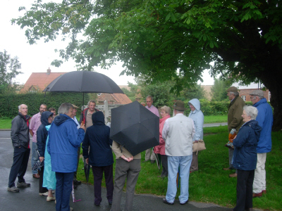
On the evening of Thursday 23rd August, Ruth Lucas and Peter Leese treated the High Wolds Heritage Group to a guided walk round Fimber.
Unfortunately, the weather was yet again unkind and everyone was in waterproofs under umbrellas. Despite the dismal, dark evening, more than 20 people came along. The couple on the right were from Sandhurst in Surrey! – They were on their annual caravan holiday staying at Wetwang.
Despite the poor weather, everyone enjoyed the tour and many were surprised by the number of dwellings in this small village.

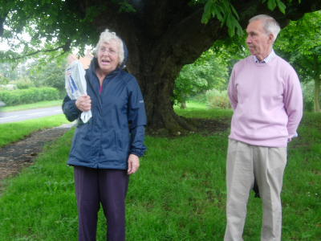

Ruth Lucas engaged us with tales of growing up in Fimber and riding on the “Malton Dodger” train to school in Malton, when she had to ride her bicycle down to the station at Fimber roundabout, and of the day in the winter of 1947 when the train was snowbound.
Peter Leese told the tale of “The Battle of Fimber Pond” between villagers of Fimber and Fridaythorpe.

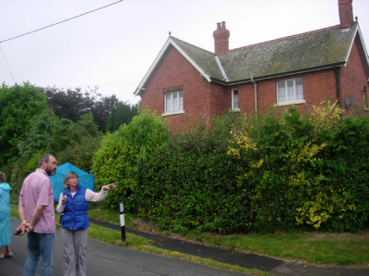
Karen, Ruth’s daughter, points out something of interest to Steve Bence in front of Manor Farm house.

Mortimer, the famous antiquarian, lived in Fimber.
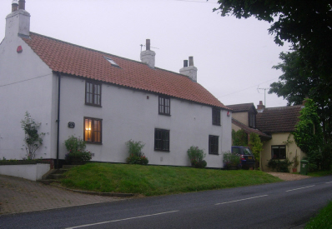
The house where he first went to school is the house shown here painted cream. It is “West Cottage”, the last house on the left hand side on leaving the Village towards Fridaythorpe.

The large house in the photo is “The White House” where Mortimer's relatives, the Welburns, lived.

We were later shown “The Gables”, the site of Mortimer’s home which was replaced by the current house.

The guided walk ended with a convivial bring-&-share supper in Fimber Village Hall.
It was a most enjoyable evening. “Thank you” – Ruth and Peter!

